Chemistry Exercises
Student’s Name
Institutional Affiliation

Chemistry Exercises
Assignment2
Question 1.
In experiment 2 and 3, the concentration of NH4 Calculate the concentration of dinitrogen pentoxide in the reaction vessel after 350 seconds
In experiment 2 and 3, the concentration of NH₄ ⁺ is maintained constant and (NO₂⁻)
Is increased by a factor 1.5. thus, the rate of reaction is increased by 1.5 times
This implies orders of the reaction with respect to B is 1st order
Comparatively,
By observing experiment one and 2
[NH⁺₄] is doubled from 2 to 1
[NO⁻] remains constant
The rate of reaction is also doubled so, reaction is first order to A (A=NH₄⁺)
Therefore, rate law=KC_{A}C_{B=K [NH4}⁺_{] [NO2} ⁻]
Rate A = _{K [NH4}⁺_{] [NO2} ⁻]
When concentration changes by a factor and when the same change is observed in rate then it 1st orders/consider any given data
b. πA= K _{[NH4}⁺_{] [NO2} ⁻]
7.6×10⁻⁶= _{K (0.24) (0.1)}
K=$\frac{7.6×10-6}{(0.24) (0.1)}$=0.000302m
- [NH⁺₄] =0.39m, [ _{NO2} ⁻] =0.056M
Rate k[NH⁺₄] [ _{NO2} ⁻]
0.000302×0.056×0.39
Rate=6.596×10⁻⁶
Question2.
The following data were obtained in a kinetic run from the decomposition of gaseous dinitrogen pentoxide at a set temperature
2N₂O_{5(g)4(NO2) (g)+O2} (g)
Graphically determine the order of reaction
ln [N2O5]t / [N2o5]o = - kt
2.303 xlog[ 61x10^-4] /[2x10^-2] = - k x700
2.303 x log [30.5x10^-2]= -700k
log30.5x10^-2 = - 303.95137k
-2 + 1.4843 = -303.95137k
k = 1.69665x10^-3s^-1
c-[N2O5]o= .02 mol/L t= 350sec
2.303xlog [0.02] /[N2O5]t = 1.69665x10^-3x350
log [0.02]/[N2O5] = 257.85x10^-3
taking antilog both side
0.02 / [N2O5] = 1.81
[N2O5]=0.011 mol/L
a-[N2O5] ln [N2O5]
0.02 -3.91
0.0169 -4.080
0.0142 -4.2545
0.0120 -4.4228
0.0101 - 4.5952
0.0086 - 4.7559
0.0072 -4.9336
0.0061 -5.009
when we polt a graph of ln [N2O5] vs time we get straight line so it is a 1st oder reaction.
graph of [N2O5] vs time is attached.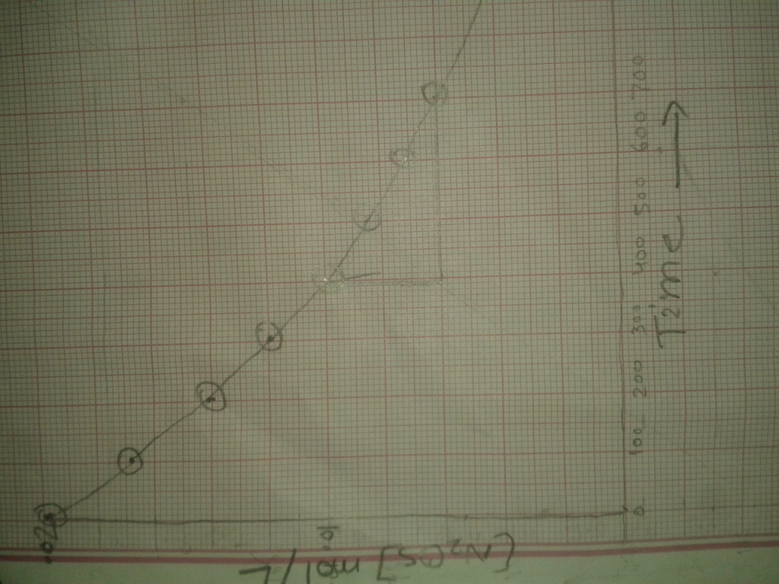

Question .3
Let’s start with the knowns:
t1/2 = 4.5x109 years
Ratio of U to Pb: 8:1 (when converting ratios into percentages you have to add both numbers to get the two number of molecules, then take each number and divide it by the sum)
This means the 11.1% is lead and 88.9% (we can use these numbers in the half-life equation)
If the initial quantity (No) of Uranium was 1 (units don’t matter), final Uranium is 0.889.
Half-life equation:
N(t) = No(1/2)t/(t1/2)
0.889 = (.5)t/(4.5E9), natural log of both sides
ln (.889) = (t/4.5x109)ln(.5) , solve for t
(ln(.889)/ln(.5)) x 4.5x109 = t ; (0.170)(4.5x109) = t
t = 7.63851x108 years
so, the age of the rock is 0.764 billion years old
Question 4.
a)
we have:
[NOCl]o = 0.45 M
t = 12600.0 s
k = 2.8*10^-5 M-1.s-1
use integrated rate law for 2nd order reaction
1/[NOCl] = 1/[NOCl]o + k*t
1/[NOCl] = 1/(0.45) + 2.8*10^-5*12600
1/[NOCl] = 2.2222 + 2.8*10^-5*12600
1/[NOCl] = 2.575
[NOCl] = 0.388 M
Answer: 0.39 M
b)
95 % is completed, means 5 % is remaining
we have:
[NOCl]o = 100 M (Let initial be 100 M)
[NOCl] = 5.0 M (5 % is remaining out of 100)
k = 2.8*10^-5 M-1.s-1
use integrated rate law for 2nd order reaction
1/[NOCl] = 1/[NOCl]o + k*t
1/(5) = 1/(100) + 2.8*10^-5*t
0.2 = 0.01 +2.8*10^-5*t
2.8*10^-5*t = 0.19
t = 6786 s
= 6786/3600 hr
= 1.9 hours
Answer: 1.9 hours
Question5.
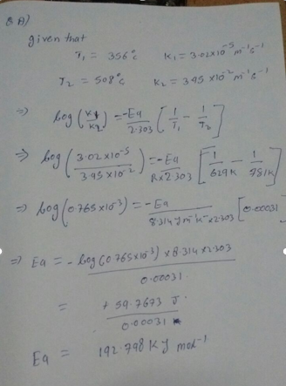
Question 6.
Part A
What is the overall reaction?
What is the overall reaction?
NO2Cl(g)?NO2(g)+Cl2(g)
2NO2Cl(g)?2NO2(g)+Cl2(g)
2NO2Cl(g)?NO2(g)+Cl2(g)
NO2Cl(g)?2NO2(g)+Cl2(g)
Part B
What is the molecularity of the first elementary step?
Unimolecular
bimolecular
termolecular
Part C
What is the molecularity of the second elementary step?
Unimolecular
bimolecular
termolecular
Part C
What is the molecularity of the second elementary step?
Unimolecular
bimolecular
termolecular
Part D
What rate law is predicted by this mechanism if the first step is rate-determining?
Rate=k[NO2Cl]
Rate=k
Rate=k[NO2Cl]2
Rate=k[NO2Cl][Cl]
Question 7.
a(i)-collect the oxygen generated and find its number of moles.
no. of moles of water = 2*no. of moles of oxygen
by these 2 measurements you can find the rate of reaction
just measure the amount at 2 different time intervals
a(ii) bromine is heavier than air and will settle at the bottom. Use any standard method to measure bromine content to measure amount of bromine at 2 different time intervals to get rate of reaction
Also, you can use the fact that bromine is readily water soluble whereas hydrogen is not. Pass water through the bromine hydrogen mixture.
(b) question is not clear
no. of moles of water = 2*no. of moles of oxygen
by these 2 measurements you can find the rate of reaction
just measure the amount at 2 different time intervals
a(ii)bromine is heavier than air and will settle at the bottom. Use any standard method to measure bromine content to measure amount of bromine at 2 different time intervals to get rate of reaction
also, you can use the fact that bromine is readily water soluble whereas hydrogen is not. Pass water through the bromine hydrogen mixture.
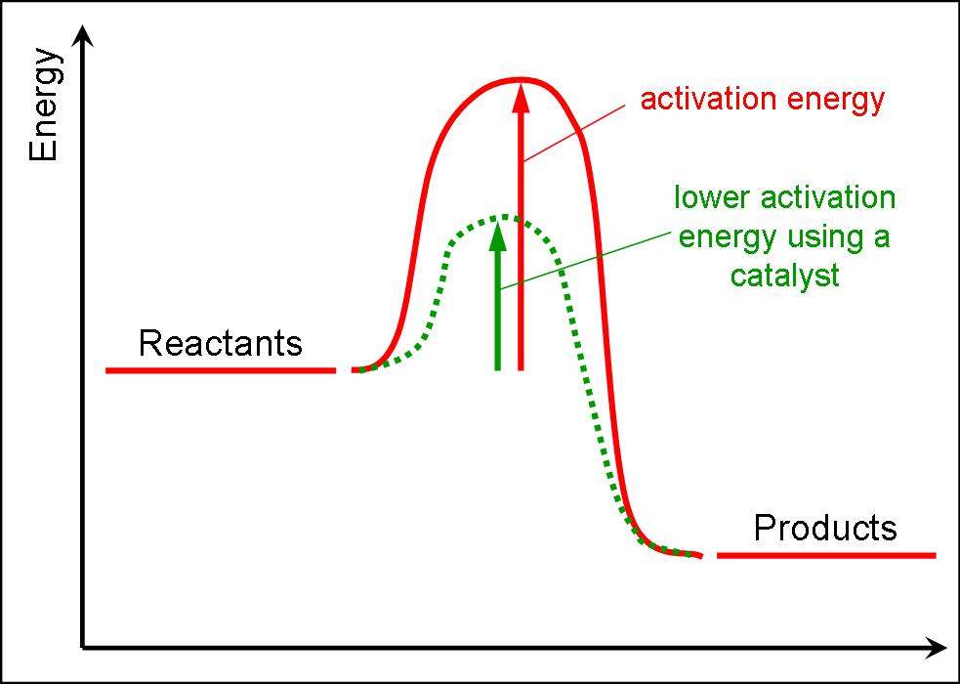

Assignment 3
Question 1
Initial concentration of N2O4 (0.500 mol) / (4.00 L) = 0.125 M
At equilibrium N2O4 concentration = (0.125 M) (100% - 79.3%) = 0.0259 M.
Hence, NO2 concentration is (0.125 M) (2) (79.3%) = 0.198 M at equilibrium.
At equilibrium,
Kc = [NO2] ² / [N2O4],
therefore
Kc = (0.198) ² / (0.0259 M) = 1.52.
Question 2
Change | Direction of reaction | Equilibrium Constant
Removal of Cl2 | Reaction moves to the left
Addition of Solid Si | No change
Decrease of temperature |  | Increases
Decrease of volume | Move to the right
Addition of He gas | No change
Addition of a catalyst |  | No effect

Question 3
For the reaction
2HI (g) H2 (g) + I2 (g)
At 458degrees Kc is 2.59 × 10. A one-liter cylinder at 458 degrees Celsius is found to contain 0.36 moles of HI (g), 0.15 moles of I2(g) and 0.18 moles of H2 (g). Is this system at equilibrium?
Question 4
PCl3(g) + Cl2(g) PCl5(g)
Change in moles of gas Δn = 1 - 2 = -1
Temperature T = 250 deg C = 523 K
Molar gas constant R = 0.08206 atm.L/mol.K
Kc = Kp x (RT)^{-Δn}
= 0.952 x (0.08206 x 523)¹
Hence
Kc = 40.9
Question 5
Initially, the concentration of H₂ and CO₂ is (1.00 mol)/(5.00 L) = .2 M.
Once the reaction has taken place, the concentrations changes to
H₂ = .2-x; CO₂ = .2-x ; CO = x ; H₂O = x.
Therefore,
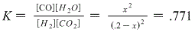
Solving this gives
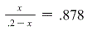
Hence
[H₂] = .2 - .0935 = .1065
and
[H₂O] = .0935
File 2
Question 6
2NOCL (g) 2NO (g) + Cl2 (g)
Kc = 2.0 x 10 at 25 degrees Celsius.
Calculate the concentration of all the species at equilibrium at this temperature.
[NOC1] = $\frac{1 mole }{4 L}$
= 0.25M
K = 2.0 x 10^{-1°}
From the reaction:
2NOCL (g) 2NO (g) + Cl2 (g)
I(M) 0.25 0 0
C(M) -2x +2x +x
E(M) 0.25 - 2x 2x
k ₌ $\frac{\left[NO\right]2 [Cl2] }{\left[NOCl\right]2}$
2.0×10⁻¹⁰ = $\frac{\left(2x\right)2 (x) }{\left(0.25-2x\right)2}$
From the above equation
x = 1.46 x10⁴
Hence, at equilibrium:
[N0] = 2.92 x10⁴ M
[C1₂] = 1.46 x10⁴ M
[NOCl] = (0.25-2.92x10⁻⁴)
= 0.25 M
Question 7
N2O4 --- 2NO3 (g)
K = 4.66 ×10⁻³

- Initially the mole of N₂0, was 0.800 mol
If x is the equilibrium moles of the gases.
N2)4 (g) --- 2NO2(g)
I(mol) 0.800 0
C(mol) —x +2x
E(mol) 0.800—x 2x
The total volume is 1.00 L the equilibrium concentration and equilibrium moles at sane.
Kc = $\frac{\left[NO2\right]2}{[N2O4]}$
4.66×10⁻³ = $\frac{\left(2x\right)2}{0.800-x}$
Solving the above equation
x = 0.0299M
At equilibrium the Concetration of [NO2] = 2x = 0.0598M
At equilibrium the concentration of [N2O4] = 0.0800-x = 0.770M
- Given that the volume is halved to give 0.500L
Then, the concentration at equilibrium would be
E (M) $\frac{0.800-x}{0.500}$ and $\frac{2x}{0.500}$
Kc = $\frac{\left[NO2\right]2}{N2O4}$
Hence 4.66 × 10⁻³ = $\frac{(\frac{2x}{0.500})}{(\frac{0.800-x}{0.500})}$
Solving the above equation
X² + 2.33× 10⁻³ x-1.86× 10⁻³ = 0
X = 0.0213M
The concentration of [NO2] at equilibrium = 2x=0.0426m
The concentration [N2O4] = 0.800-x = 0.779M
Question 8
Using the Ksp values given in table 16.2 of your textbook,
- The solubility of Calcium phosphate in water would be
Ca₃(PO₄) => 3Ca²⁺ + 2 PO₄³⁻
Ksp = [Ca²⁺]³[PO₄³⁻]² = (3x)³ (2x)² = 108x⁵
108x⁵ = 1.2×10⁻²⁶
x⁵ = 1.111×10⁻²⁸
x = 2.6×10⁻⁶ mol/L
= molar solubility of Ca3(PO4)2
b.) Calcium phosphate in 0.010M CaCl2 solution
Ksp = [Ca²⁺]³[PO₄³⁻]²
1.2×10⁻²⁶ = (0.01)³ (2x)²
In this case, x is the molar solubility in the solution
4x² = 1.2×10⁻²⁰
x² = 3.0×10⁻²¹
x = 5.5×10⁻¹¹ mol/L = molar solubility in this solution
Question 9
- Which hydroxide precipitate first as NaOH is slowly added to the solution?
YOH Y+ + OH-
Ksp = [Y+][OH-] = 1.0 x 10⁻¹²
when [OH-] = Ksp/[Y+], YOH precipitates
Hence,
[OH-] = Ksp/[Y+] = 1.0 x 10⁻¹²/0.0010 = 1.0 x 10⁻⁹ M
Z(OH)2 Z2+ + 2 OH-
Ksp = [Z2+][OH-]² = 1.0 x 10⁻¹²
when [OH-] = (Ksp/[Z2+])^{1/2} , Z(OH)2 precipitates
So,
[OH-] = (Ksp/[Z2+])^{1/2} = (1.0 x 10⁻¹²/0.0010)^{1/2} = 3.16 x 10⁻⁵ M
From the above equation, it is evident that YOH precipitates out first
(b)
When Z(OH)2 starts to precipitate out, [OH-] = 3.16 x 10⁻⁵ M
[Y+] = Ksp/[OH-]= 1.0 x 10⁻¹²/3.16 x 10⁻⁵ = 3.2 x 10⁻⁸ M
Question 10
Given Data
Mass of NaOH=2.20g
Molar mass of NaOH=40g/mol
nNaOH=$\frac{2.20g}{40.0g/mol}$=0.055mol
Volume of FeCl2=250ml
[FeCl₂] =0.10M
Nfecl2=0.250 L×0.10M=0.025moles
The reaction of chemical
Fe²⁺ (aq)+20H⁻ Fe (OH)₂(s)
Therefore, Fe²⁺reacts with 2mole of hydroxide ions
Thus 0.025 moles of Fe²⁺ reacts with 2× 0.025 moles of hydroxide ions hence 0.050 moles. Therefore, OH⁻ is excess and Fe²⁺ is the limiting reagent.
From the chemical reaction, 0ne mole of Fe²⁺forms one mole of Fe (OH)_{2.} Thus 0.025moles Fe (OH)₂ is formed.
Molar mass of Fe (OH)₂₌89.86g/mol hence mass of Fe (OH)₂(s)=0.025mol×89.86g/mol=2.3g
Chemical reaction:
Fe (OH)₂ (s) Fe²⁺(aq)+2OH⁻(aq)
At equilibrium
K_{sp}= [Fe²⁺] [OH⁻]²
1.6¹⁰=(s)(2s)²
4^{s3}=1.6×10⁻¹⁴
S=$\sqrt[1/3]{\frac{1.6×10-14}{4}}$
=1.6×10⁻⁵mol/L
Hence [Fe²⁺] =1.6×10⁻⁵mol/L

Assignment 4
Question 1
- Trichloroacetic acid is stronger than acetic acid because it has an excess of three chlorine electrons, which have high electronegativity. The excessive electrons and their withdrawing effects lead to stabilization effects on the anion making it stronger than the acetic acid.
- Balanced net ionic equation (s) for the reaction (s) of HSO4 ion with water
Molecular equation: HSO₄ (aq) + H₂O (l) H₃O (aq) + SO₄ (aq)
Ionic equation: H+ (aq) + SO₄²⁻ + H₂O (l) H⁺ (aq) + H₂O (aq) + SO₄²⁻
Net Ionic equation: SO₄²⁻ + H₂O (l) H₃O⁺ (aq) + SO₄²⁻ (aq)
- Lewis acid refers to an electron acceptor while Bronsted-Lowry acid refers to proton donor. Examples of Bronsted-Lowry acid include acetic acid, hydrochloric acid and ammonium cation. An example of a Lewis acid is Hydrogen cation (H⁺).
- Conjugate bases give basic solutions while the aqueous solutions of other conjugate bases remain neutral
Some conjugates yield basic solution particularly when conjugate base and conjugate acid have unequal strengths. On the other hand, conjugate acid and base have equal strengths the resulting solution is neutral.
- For a 0.15M solution of pyridine, calculate pOH, pH, percent ionization of this weak base and formula of conjugate acid of pyridine
C₅H₅N + H₂O C₅H₅NH+ + OH-
Kb =[OH-][C₅H₅NH+]/[C₅H₅N]
1.77 x10^-9 = x^2/(0.15-x)
x = [OH-] = 1.633 x10^-5
a) pOH = 4.79
b) pH = 9.21
c) % ionization =[C5H5NH+] x100/[C5H5N] = 1.633x10^-5 x100/0.15
= 0.0109 %
d) C5H5NH+

Question 3

Let pOH be x
The kb of ammonia = 1.8×10⁻⁵
x=√(1.8×10⁻⁵)(0.15)
x= 5.1×10⁻³
-log(5.1×10⁻³)
=pOH = 2.79
Hence,
pH = 14-2.79
pH=11.71

KNO2(s) ----> K+(aq) + NO2-(aq)
NO2-(aq) + H2O(l) <---> HNO2(aq) + OH-(aq)
Kb = [HNO2][OH-]/[NO2-]
Ka = 4×10^-14
Kw = Ka×Kb
Kw = 10⁻¹⁴
Ka = 4×10⁻⁴
Kb = Kw/Ka = (10⁻¹⁴)/(4×10⁻⁴) = 2.5×10⁻¹¹
Kb = [HNO2][OH-]/[NO2-]
[HNO2] = [OH-] = x
[NO2-] = 0.5 M
Substituting all values
Kb = [HNO2][OH-]/[NO2-]
2.5×10⁻¹¹ = x*x/(0.5)
Solving for x
x = √ ((2.5×10⁻¹¹)(0.5)) = 3.5355×10⁻⁶
Since [OH-] = x = 3.5355×10⁻⁶
pOH = -log(OH) = -log(3.5355×10⁻⁶) = 5.45
But we need pH
pH = 14- pOH = 14-5.45 = 8.55
pH = 8.55

c)
KNO2(s) ----> K+(aq) + NO2-(aq)
NO2-(aq) + H2O(l) <---> HNO2(aq) + OH-(aq)
Kb = [HNO2][OH-]/[NO2-]
Ka = 4×10⁻¹⁴
Kw = Ka×Kb
Kw = 10⁻¹⁴
Ka = 4×10⁻⁴
Kb = Kw/Ka = (10⁻¹⁴)/(4×10⁻⁴) = 2.5×10⁻¹¹
Kb = [HNO2][OH-]/[NO2-]
Assuming that there is 1 mol of HNO2 per 1 mol of OH- which can be assigned "x"
[HNO2] = [OH-] = x
[NO2-] = 0.15 M
Substituting
Kb = [HNO2][OH-]/[NO2-]
2.5×10⁻¹¹ = x*x/(0.15)
solving for x
x = √ ((2.5×10⁻¹¹)(0.15)) = 1.94×10⁻⁶
Since [OH-] = x = 1.94×10⁻⁶
pOH = -log(OH) = -log(1.94×10⁻⁶) = 5.71
Since only pH is needed,
pH = 14- pOH = 14-5.71 = 8.29
So, the pH = 8.29
Question 4

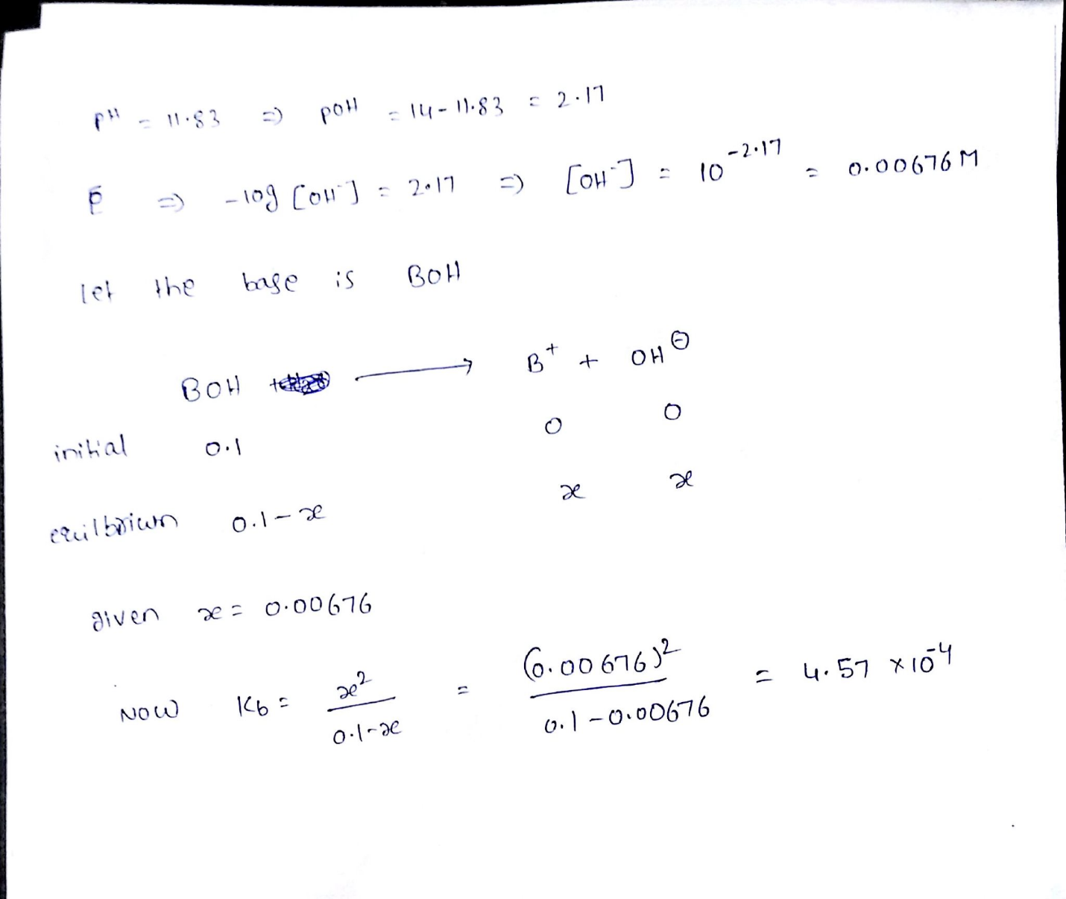

b)
C₆H₅OH(aq) + H₂0(l) C₆HSO-(aq) + H₃0+(aq)
or
C₆H₅OH(aq) C6HSO-(aq) + H+(aq)
NH4+(aq) + H₂0(1) NH3(aq) + H30+(aq)
ii) Kpa for C6H5OH = -log (1.3×10⁻¹⁰)
= 9.886
Kpa for NH4+ = -log (5.6×10⁻¹⁰)
= 9.2518
iii) Higher pka shows lower acidity. Hence C6H5O- is more basic than NH4+ since it has higher kpa.
Question 5
a)
Total Volume = 25+25 = 50
mmol of HClO4 total = (25×0.1) + (25×0.15) = 6.25
[HClO4] = mmol/V = 6.25/50 = 0.125 M
[H+] = [HClO4] = 0.125 M
b)
mmol of acid = MV = 0.025×25 = 0.625
mmol of base = MV = 0.015×25 = 0.375
after reaction
mmol of acid left = 0.625-0.375 = 0.25
mmol of conjugate formed = 0.375
pH = pKa + log(A-/HA)
pKa = -log(Ka) = -log(1.37*10^-4) = 3.8632
pH = 3.8632+log(0.375/0.25)
pH = 4.03929
[H+] = 10^{-pH} = 10^{-4.03929} = 0.0000913
c)
Final Volume = 25+25 = 50 mL
[Acid] = 0.1 M
Ka = [H+][H2A-]/[[H3A]
10^{-3.15} = x*x/(0.1-x)
x = [H+] = 0.008067
d)
mmol of base = MV = (2.5×10⁻³)×(25) = 0.0625
mmol of acid = MV = (1.25×10⁻³)×(50) = 0.0625
Neutralization:
[nicotine acid] = mmol/V = (0.0625)/(25+50) = 0.00083
Let B --> CH3NH2 and BH+ = CH3NH3+ for simplicity
the next equilibrium is formed, the conjugate acid and water
BH+(aq) + H2O(l) <-> B(aq) + H3O+(aq)
Since equilibrium is best described by Ka,
Ka is a base:
Ka = [H3O][B]/[BH+]
From ICE table:
[H3O+] = 0 initially,
[B] = 0
[BH+] = M
the Change
[H3O+] = 0 + x
[B] = 0 + x
[BH+] = -x
in Equilibrium
[H3O+] = 0 + x
[B] = 0 + x
[BH+] = M - x
substituting in Kb expression
Kb = [HA ][OH-]/[A-]
Ka = Kw/Kb = (10^-14)/(1.05*10^-6 = 9.523*10^-9
9.523×10⁻⁹ = x*x/(0.00083-x)
solving for x
x² + Ka*x - M*Ka= 0
solving for x with quadratic equation
x = H3O+ =2.81×10⁻⁶
[H+] = 2.81×10⁻⁶ M
Question 6
Construct a pH titration curve for 50ml of 0.1M butyric acid against added 0.1M KOH solution
Question 7
pH = pKa + log [conjugate base]
[acid]
3.50 = 3.86 + log [CH3CH(OH)COO-]
[CH3CH(OH)COOH]
-0.36 = log [CH3CH(OH)COO-]
[CH3CH(OH)COOH]
10-0.36 = 0.44
base:acid 0.44:1.
Hence,
0.44 L of 0.10 M NaOH reacts with 1 L of 0.10 M lactic acid to produce 1.44 L of solution.
0.44x + 1x = 800mL
1.44x=800
x= 556.
800mL - 556mL = 244mL
To produce 800mL buffer solution with a pH of 3.50, one would require
244mL of 0.10 M NaOH and 556 mL of 0.10 M lactic acid.
8a)
For the additional 0.10 g of NaOH
Lactic acid = C3H6O3
C₃H₆O₃ (aq) + NaOH (s) C₃H₆O₃Na (aq)+ H₂O (l)
The pH of the buffer = 3.5.
The addition of 0.10 g/40.0 g mol⁻¹ = 2.5 x 10⁻³ moles of OH- forces the equilibrium to the right. The OH- reacts completely with the H+ from the lactic acid in the buffer solution
It forms water, removing hydrogen ions from the solution.
In 800mL of the buffer solution, there is (0.10 M x 0.556L x 0.800L =) 0.04 moles of NaOH.
8 b)
adding 2.5 x 10⁻³ moles of NaOH, makes 0.0425 moles of NaOH.
pH = pKa + log [conjugate base]
[acid]
pH = 3.86 + log [(0.0425 x 0.800]
[0.016]
pH = 4.19
Adding 0.10 g of NaOH to the buffer solution gives a new pH of 4.19
Question 9)
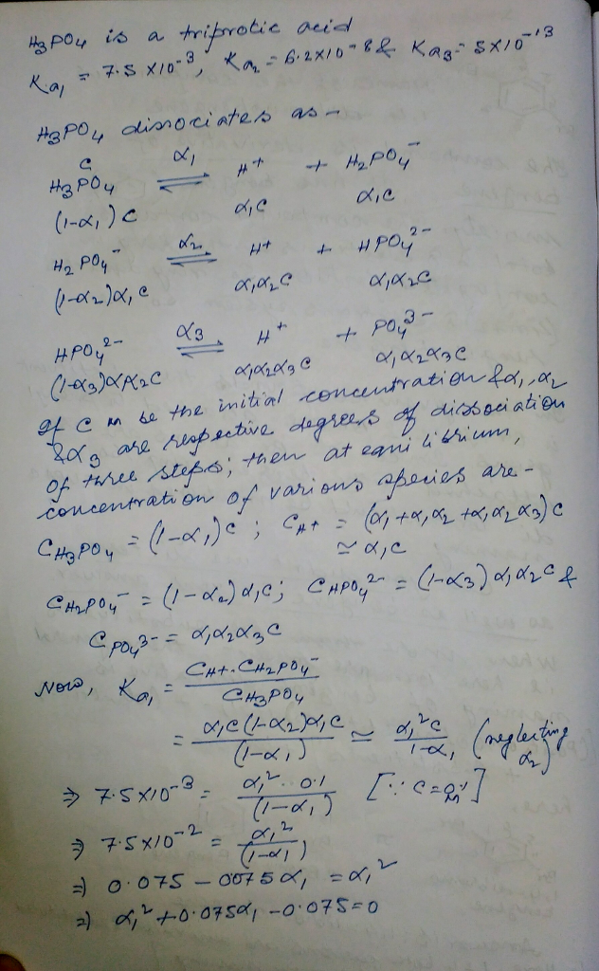
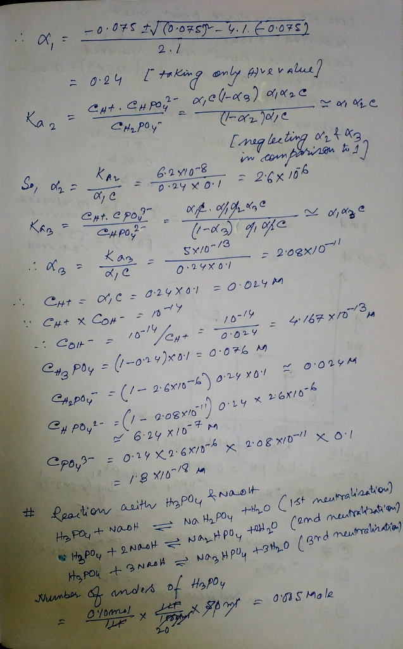
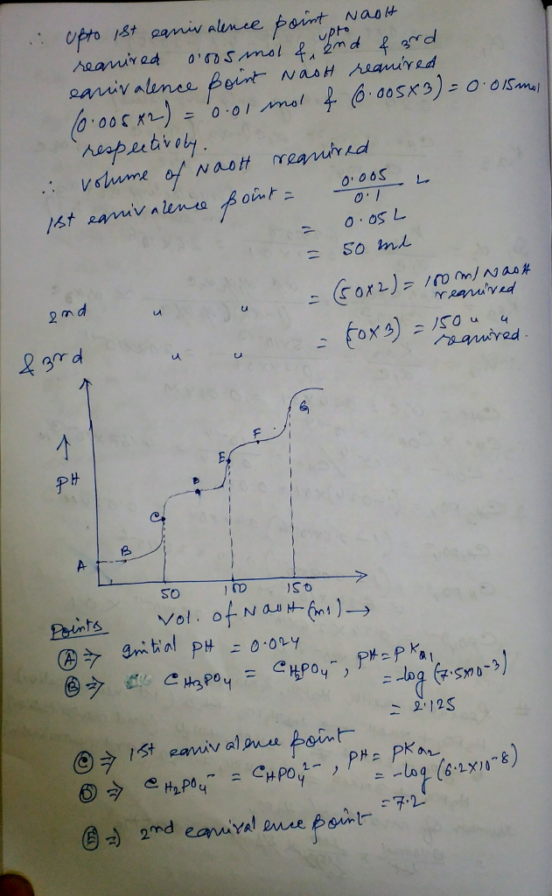
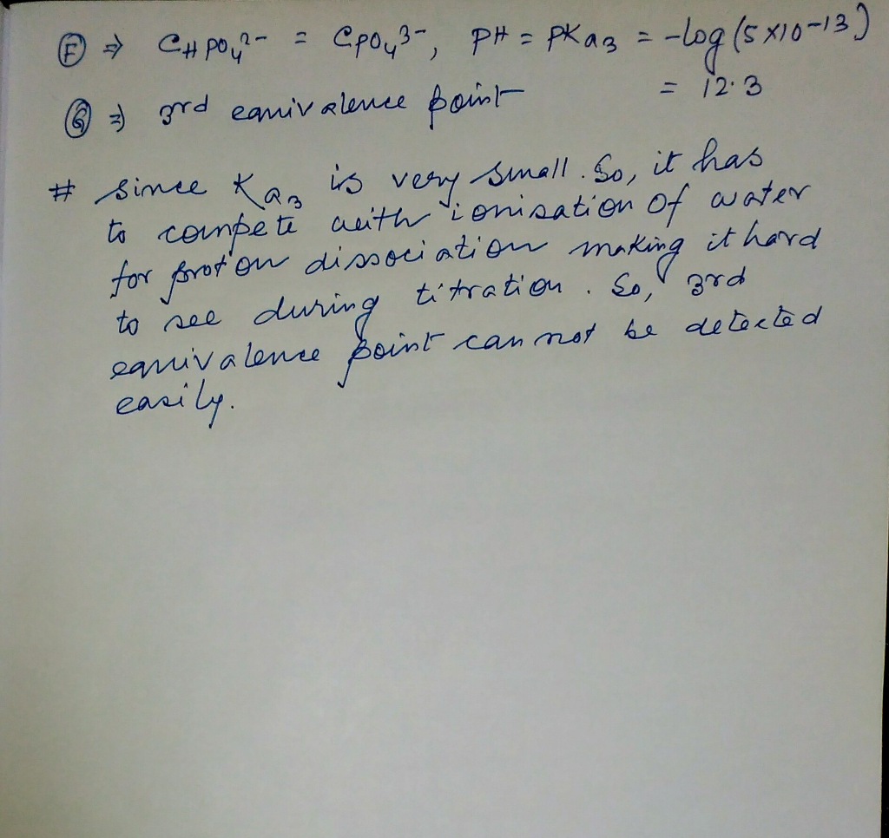

Question 10
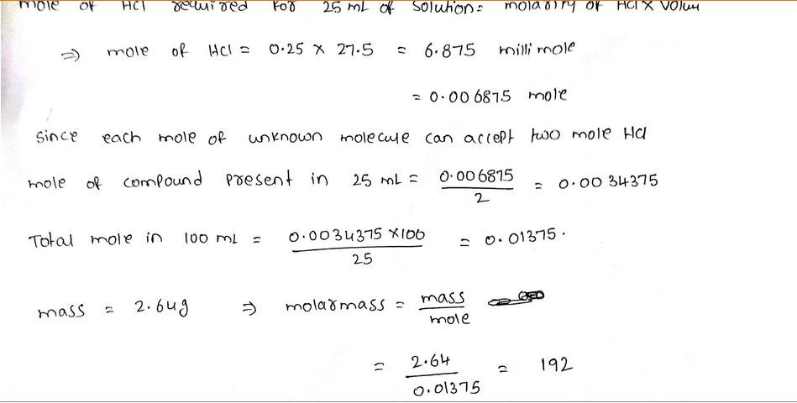

Assignment 5
Question 1
Identify the following systems as open, closed or isolated
- A coolant in refrigerator coil is considered as a closed system because it can only exchange energy and not matter.
- A bomb calorimeter can be considered as an isolated system because it does not allow matter or heat to pass.
- From the first law of thermodynamics,
- Q = E +W where Q is heat flow, E = increase in internal energy and W= work done.
Change in E = Change in Q – W
Hence E = Q-W
650kJ-(-800kJ))
E = 1450kJ.
Question 2
From the data,
NH 3 + HCL --- NH4CL H = -176
N2 + 3H2 --- 2NH H = 92.2
N2 + 4H2 --- 2NH4Cl H = -628
calculate H for the reaction
Question 3
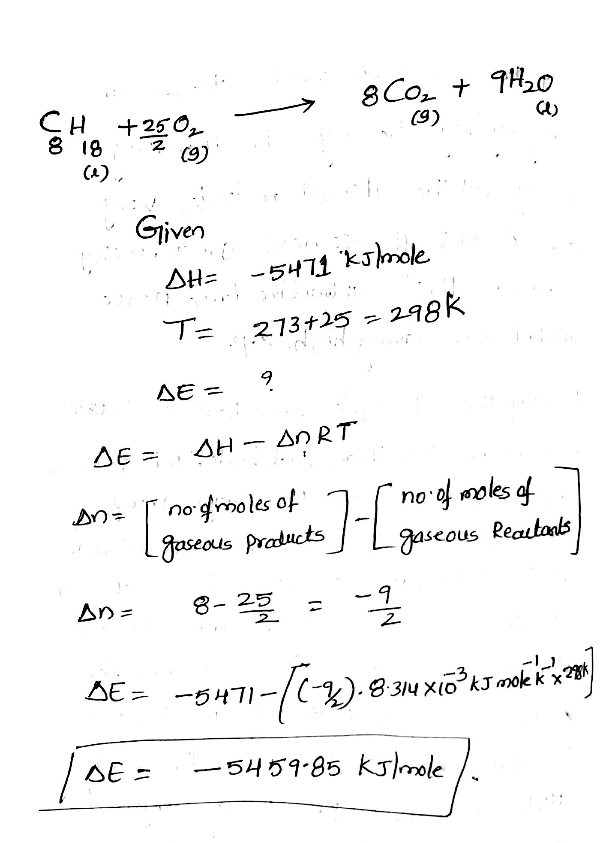
Question 4
List the following substances in the order of increasing molar entropy at 25 degrees Celcius H2O(l), H2O (g), H2O (s) and Ar (g)
- H2O(s) < H2O(l) < H2O(g) < Ar (ag)
As indicated in the above equation, solids have a lower entropy than liquids. Likewise, liquids have lower entropy than gases. Hence, H20(g) is likely to have higher entropy than H2O (l) and H2O 9s)
Question 5
AHvap = 30.8 kJ/mot = 30800 J/mot T= 78.3 deg C = 351.45 K
AGvap = AHvap - TASvap = 0
ASvap = AHvap/T
= 30800/351.45 = 87.637 J/mol.K
Moles of benzene = mass/molar mass = 11.5/78.11 = 0.1472 mot
Entropy change AS = moles x ASvap = 0.1472 x 87.637
=12.9 J/K
Question6
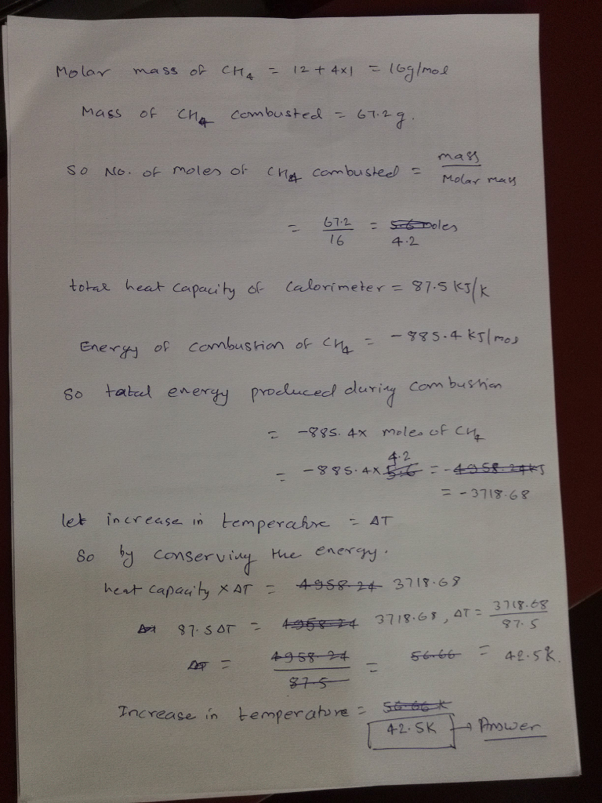

Question 7
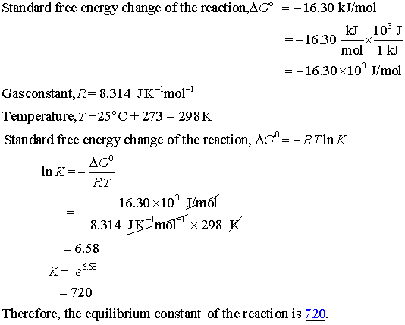
Answer; equilibrium constant of the reaction = 720
Question 8
mol wt of octane =114.33g
114.33*2 g of octane when reacted ΔH is=-11018kJ
∴when 100g of octane when reacted ΔH is=-11018*100/114.33*2kJ
=A. -4.82 x 103 kJ
Question 9
At equilibrium
dG° = dH - TdS
dG° = 0 at euqilibirum
Therefore
dH = TdS
T = dH/dS
dH = Hprod - Hreact = (4*HFe + 3*HCO2) - (2*HFe2O3 + 3HfC) = (4*0 + 3*−393.51) - (2*−824.2 +3*0) = 467.87 kJ
dS = Sprod - Sreact = (4*SFe + 3*SCO2) - (2*SFe2O3 + 3SfC) = (4*27.3 +3*213.6 ) - (2*87.4 +3*5.7 ) =558.1 J/K
T = dH/dS = 467870/558.1 = 838.3 K
but that is the equilibrium temperature
anything greater than that temperature will be spontaneous
Hence,
T=838.3 K
Question 10
For th phosphine reaction,
a) dHo = 28 kJ/mol
So at T = 298 K,
dSo = dHo/T = 28/298 = 0.094 kJ/K-mol
the reaction is spontaneous as the sign of dSo is +ve.
b) An increase in entropy suggests the phosphine can exist well as a possibility. The formation of phosphine as shown above is spontaneous and thus phosphine may exist as a stable product under the given conditions.

Assignment 6
Question 1
LHS (Left hand side) is anode and RHS (Right hand side) is cathode.
- Ag₂S(s) +2e⁻ < --------> 2AG(s) + S²⁻ (aq) (-0.17v [anode])
2HCLO₂ +2H⁺ + 2e⁻ < -------> CL₂ +2H₂O (1.63V [1.63V])
Overall reaction: 2Ag(s) + S²⁻ (aq) + 2HCLO₂ + 2H⁺ < ------> Ag₂S(s) + CL₂ +2H₂O

E⁰ cell = Cathode – anode
=1.63 V-(-0.17V) =1.8V

- Pt|Cr₂O₇²⁻+ 6e⁻ +14H⁺ <-----> 2Cr⁺³ + 7H₂O (1.33V [anode])
Cl₂ + 2e⁻ <---> 2Cl (1.3595V [cathode])
E⁰ cell = Cathode - anode
=1.3595 V-(1.33V) = 0.0295V
- Fe⁺³ + 3e⁻ <---> Fe (-0.04V [anode])
HgCl_{2(S)} + 2e⁻ <---> 2Hg (l) + 2Cl⁻ (0.27V [cathode])
Overall reaction : Fe + HgCl_{2(S)} <-----> Fe⁺³ + 2Hg (l) + 2Cl⁻
E⁰ cell = Cathode - anode
= 0.27 V-(-0.04V) = 0.31V

Question 2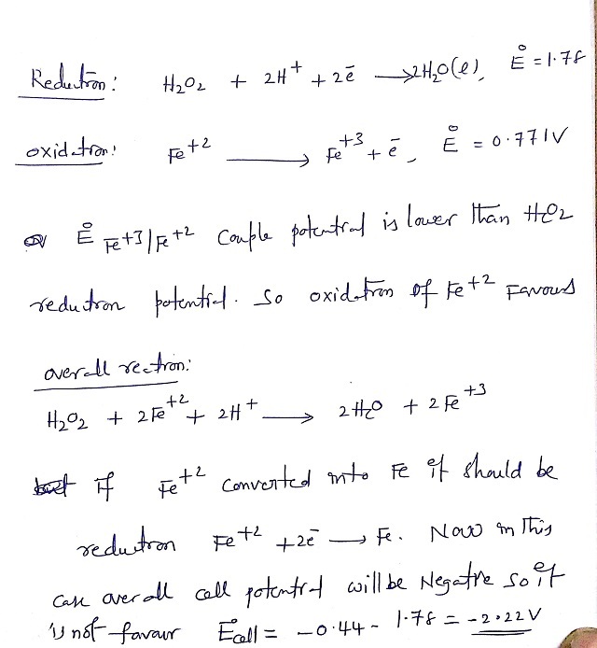

Question 3
- This is because of the series of activities in metal and he fact that Silver does not react with nitric acid as it would release hydrogen gas. This is due to the fact that silver is below hydrogen in the reactivity series. Nevertheless, Nitric acid is an oxidizing agent and, in this sense, it will oxidize silver metal into AG⁺, therefore being reduced to a lower state of oxidation. Relatively, the major product is nitrogen dioxide (NO₂) which emanates as red brown fumes.
Ag + 2HNO3 --> AgNO3 + NO2 + H2O
If the acid is dilute, the major product is nitrous acid which stays in solution:
2Ag + 3HNO3 --> 2AgNO3 + HNO2 + H2O
Hydrogen just like gold it is precious so a HNO₃ will therefore not react. It is also impossible to swap metals with anything that is below hydrogen. Zinc on the other hand is above nitrogen whereby it bubbles and fizzes when it comes in contact with acids.

- Aluminum is chemically active, therefore it does not corrode in moist air compare to do iron. The oxide coating is so thin that it is transparent, so the aluminum retains its silvery metallic appearance. Sea water, however, will corrode aluminum unless it has been given an unusually thick coating of oxide by the anodizing process.
- Corrosion of copper occurs in two ways although their difference is very technical. The corrosion could be induced by a galvanic couple caused by contact with the galvanized pipes. As a result, an induced local anodic polarization of the copper wire is developed. The propensity for copper pipes to fail is related to how the pipe was made, the local water composition and the environment it is used in.
- The density of this acid is high just before the discharge is begun. It is diluted rapidly at first, but a balanced condition is reached between the density of the acid in the plates and in the main body of the electrolyte, the acid supply in the plates being maintained at a lowered density by fresh acid flowing into them from the main body of electrolyte. After the initial drop, the voltage decreases more slowly, the rate of decrease depending on the amount of current drawn from the battery.

Question 4
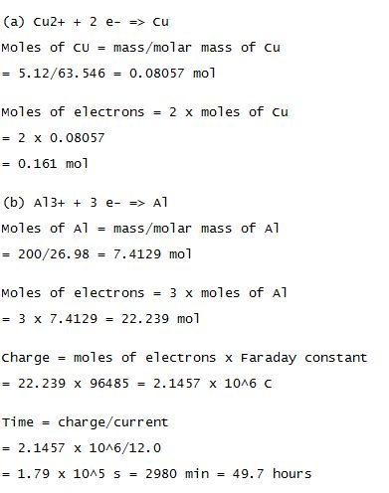

Question 5
- Using the formula,
G⁰ = -nFE⁰, here n = 2 as number of electrons is 2, F = 96500, E⁰ = +2.64V
placing the values,
G⁰ = -(2) (96500) (2.64) = -509520J = -509.52 KJ/mol
- Given, free energy of formation of HF (aq) = -276KJ/mol
we have to find free energy of formation of XeF₂(aq) =?
from (a), we have Δ_{f}G₀ = -509.52KJ/mol
using the formula,
Δ_{f}G₀=∑Δ_{f}G⁰(products)−∑Δ_{f}G⁰(reactants)
now, replacing the values,
-509.52 = 2(-276) - Δ_{f}G⁰(XeF₂)
Δ_{f}G⁰(XeF₂) = 2(-276) + 509.52
Δ_{f}G⁰(XeF₂) = -552 + 509.52
Δ_{f}G⁰(XeF₂) = -42.48 KJ/mol

Question 6
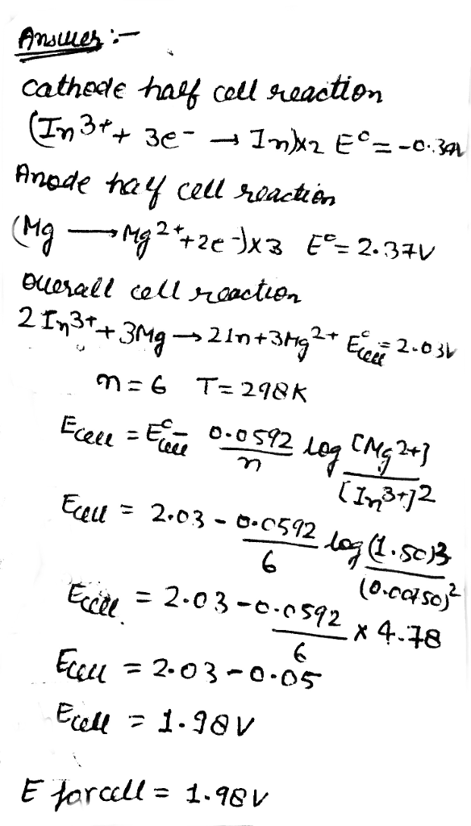
Question 7

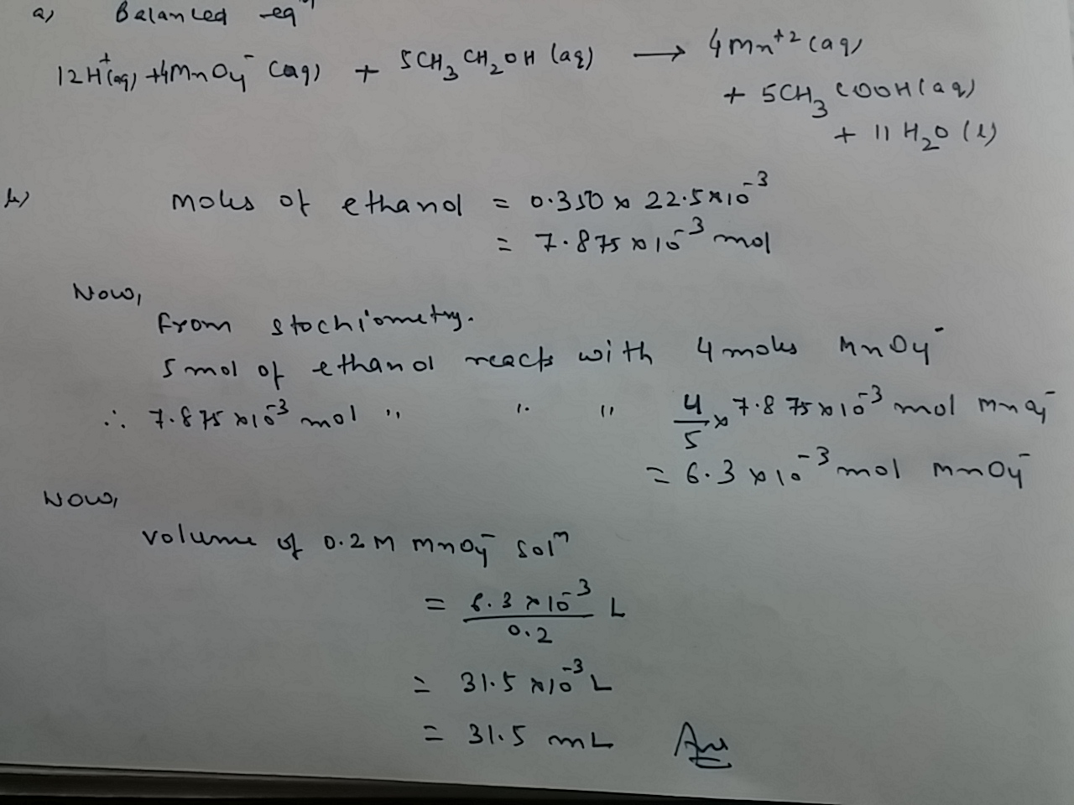
Question 8
Reduction Reaction:
2e- + H20 + 1/2 O2 (0.20 atm) --> 2OH- -0.83 V
oxidation Reaction: 2H+ + 2e- --> H2 - 0.44 V
Eºcell= Eºcathode - Eºanode
Eocell= -0.83 -(-0.44)
Eocell = -0.39 V
so,
E = Eo - (RT/nF)1n Q
E = -0.39 - 0.0257/2 V 1n (1)/1/2(o2)
Q is found from aA + bB ----> cC + dD therefore Q= {cC + dD / aA + bB}
In this situation - the H20 is a liquid, the Fe is a solid, and the Fe(OH)2 is a solid therefore it wouldn't be considered.
E = -0.39 - 0.01V (1/1/2(0.20atm)
E = -0.39 - 0.01 (2.30)
E = -0.39 - 0.02
E = -0.41 V
Question 9

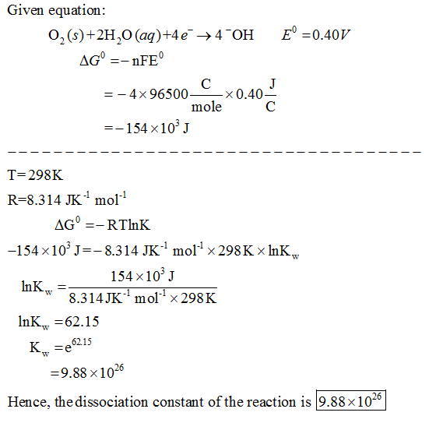
Question 10
